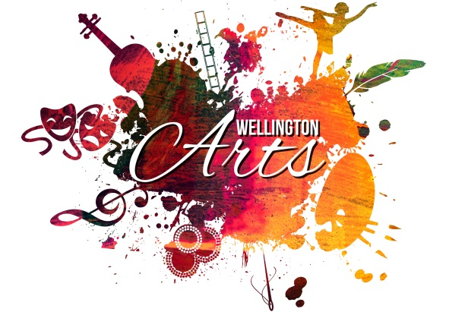
ENTRY FORM

Artist Details (please print clearly) Name _____________________________________________________________________________ Address ____________________________________________________ ______________________________________Post Code_____________
Phone _______________________________________________ Mobile _____________________________________________________________ Email ______________________________________________________________________________________________________________________ ABN (if applicable) _____________________________________________________

The work
- All artworks need to be ready to hang.
- Size and Designs need to be clearly stated to assist the Curator
- Limited 8 works per artist/photographer
- Theme of the exhibition is Summer Festival but is open to all themes
- May be painted in any medium ( eg. watercolour, acrylic, oil, mixed media, drawings)
- May be photography any size (must be in format to hang, ie. framed)

Title of work (please print clearly)______________________________________________________________________________________ Size__________________________________________________________________
Medium_____________________________________________________________
Inspiration or Concept (story about the piece)________________________________________________________________________
_______________________________________________________ ________________________________________________________________________
________________________________________________________________________________________________________________________________________________________________________________________________________________________________________________________________

Is the work for Sale? Yes No

If yes, selling price $_________________ (25% commission applies)

By signing this form I agree to participate in the Wellington Summer Festival Art Exhibition and abide with conditions outlined on this and the following page. I declare that the artwork submitted is my own original work and has been completed in the last twenty-four months.

Signature_______________________________________________ Date___________________
REMINDER Entries close: COB Friday 6th January 2017

Mailing Address: Wellington Arts PO Box 42 Wellington NSW 2820

Phone: 0428 417 548

Email: arts@wellington2820.org.au

Conditions of entry

- Please use one entry form for each artwork entered
- All works of art should have Artist’s detail on the back of artwork.
- Wellington Arts reserves the right to cull any works. The committee’s decision is final and no correspondence will be entered into
- The cost and delivery of the work remains with the artist.
- Wellington Arts will exercise every care with works exhibited but will not be responsible for any loss or damage to any work, whilst in its custody or in transit.
- Insurance of all works exhibited is the responsibility of the Artist.
- Wellington Arts will not pay for any costs incurred in the delivery of any entry, including freight.
- There will be a commission of 25% for artwork sold during the exhibition
- Payment of sold works will be made to artists within two weeks following the end of the exhibition
- Exhibitors grant Wellington Arts permission to reproduce the work in material form, to photograph, publish and/or communicate it to the public for marketing and publicity purposes.

Entry Forms & Fees

There are no fees attached to exhibition items.
Wellington Arts would, however, like to profile you as a local artist on our website and provide contact information on our site to assist in promoting your work. All arts professionals can be supported by our organization with an annual fee of $50.

Mailing Address: Wellington Arts
PO Box 42
Wellington NSW 2820
Ph: 0428 417 548
Email: arts@wellington2820.org.au

Cheques /Money Orders must be made out to Wellington Arts.
Electronic funds transfer to:
Wellington Arts
BSB: 082-922
Account: 73384-0541
Please show your name as reference.

